Rode and Norton St Philip School Federation

ADMISSION ARRANGEMENTS FOR
NORTON ST PHILIP CHURCH OF ENGLAND VA FIRST SCHOOL
FOR 2022/23 ACADEMIC YEAR

Norton St Philip Church of England VA First School
Church Street
Norton St Philip
Bath
Somerset
BA2 7LU
Tel: 01373 834327
Fax: 01373 834327

Admissions contact: Mrs K Twitchen
School Office email: rodeandnortoninfo@educ.somerset.gov.uk
Headteacher: Mrs G Muxworthy
School website: www.rodeandnortonschoolfederation.co.uk
Somerset Local Authority website: www.somerset.gov.uk
Norton St Philip Church of England VA First School

This policy should be taken as part of the overall strategy of the school and operated within the context of our vision, aims and values as a Church of England School

Introduction

Norton St Philip Church of England VA First School was originally established by the Church of England in 1827. The school was established to serve all within its community, those of all faiths and of none and strives to offer the highest quality education underpinned by a distinctly Christian Ethos. Our school catchment area includes the villages of Norton St Philip, Laverton and Farleigh Hungerford. Please refer to the catchment area map in Appendix 1.

In 2014 the school joined with Rode Methodist VC First School to form Rode and Norton School Federation. All Reception and Y1 children from both schools are educated at our Norton St Philip site, and all Y2, Y3 & Y4 children at our Rode site. When combined, as a Federation, we can ensure single year group classes whilst maintaining the requirements of Infant Class Size legislation (30 children to each qualified teacher unless a child qualifies as a permitted exception in accordance with section 2.15 of the 2014 School Admissions Code).

It should be noted that Rode and Norton St Philip Schools have separate admission routes:

- As a voluntary aided school (VA), Norton St Philip Church of England VA First School acts as its own Admission Authority. This Policy applies only to Norton St Philip Church of England School Admissions.
- As a voluntary controlled school (VC), the Admission Authority for Rode Methodist First School is Somerset County Council, further information on Admission Arrangements for 2021-22 can be obtained by visiting Somerset County Council​, Admissions and Entitlements Team​.

Published Admission Number (PAN)
Norton St Philip Church of England VA School has an admission number of 12 for entry into its Reception Year in September 2021. Rode Methodist VC First School has an admission number of 18 into its Reception Year. The Governors’ Admissions Committee will consider all applications to Norton St Philip Church of England VA First School. If 12 or fewer reception applications are received for September 2022, every applicant will be offered a place for their child, without condition. If more than 12 applications are received, the Admission Authority will apply the oversubscription criteria in order to rank all the applications and identify a priority for the offer of places up to the Admission number of 12.

Important Documents

Important documents published by your Local Authority are relevant to some areas of school admissions procedure. Applicants are strongly advised to contact their home Local Authority or access the Local Authority website and ensure that they read and understand this information before proceeding with an application for a school place. Related documents of particular importance are:

- The Local Authority Coordinated Admissions Scheme (this applies to starting and transferring school for the first time)
- The Composite Prospectus (primary guide for parents)
- The Local Authority Fair Access Protocol
- The Local Authority School Transport policy
- Free School Meal Entitlement

Starting School in the Reception Year Group for the first time

Parents may apply for their child to start school for the first time in the September following his/her fourth birthday. A Local Authority Common Application Form must be completed for a child starting school for the first time in September 2022 and submitted directly to the home Local Authority, to arrive no later than 23.59 hours on 15th January 2022.

The home Local Authority will forward applications directly to the Local Authority in which area the preferred school(s) is/are located. Where the application is for Norton St Philip Church of England VA First School, the Governing Body will be notified, and the governors Admissions Committee will meet and rank every application received according to the oversubscription criteria. Applications received ‘on time’ by the published closing date will be processed and places allocated before any late applications are considered. A late application closing date is published in local authority Coordinated Admissions Schemes. The governors’ allocation decisions will be notified to Somerset Local Authority in accordance with this authority’s Coordinated Admissions Scheme timetable and the home Local Authority will then inform parents of individual decisions on 16th April 2022 by email or letter post.

Admission during the 2022/23 Academic Year (In-year admission)

Applications can be submitted at any time during the academic year, by completing the governors’ in-year application form and returning this directly to the school. The application form is available to download from the school website, or a copy can be provided upon request to the school office. The governors will not consider any applications received during school holiday periods until school resumes.

The Admissions Committee will meet within five school days of the receipt of an application form. Where the request is for the child’s chronological age year group and there is a place available, the decision will normally be to admit the child concerned and applicants will be notified of this in writing. Where the governors have more than one application to consider at any one time for the same year group, they may need to apply the published oversubscription criteria in order to determine a priority for admission where insufficient places exist.

Where the requested chronological age year group is oversubscribed, the governors will carefully consider whether an additional child might still be admitted to the school without impacting on the available resources or affecting the delivery of education. Normally the decision will be to refuse admission if the year group is full and, where this is the case, parents will be notified in writing of the reasons for refusal and about how to appeal against the governors’ decision.

In-year decision letters are sent out from the School Office within 5 school days of the Admission Committee decision being taken. Applicants will be expected to confirm their acceptance of any place offered within 21 school days.

The Admissions committee may refer some in-year admission applications in accordance with the Somerset Local Authority Fair Access Protocol, where the information provided by an applicant on the school place application form indicates that the child concerned may require additional support or an alternative school provision. Applicants are advised to read the Local Authority Fair Access Protocol document before completing an in-year application form. This document can be downloaded and/or read on the Somerset Local Authority website.

Over Subscription Criteria

Where there are more applications than there are places available within the required year group, the governors will consider all applications received against the oversubscription criteria set out below. This will enable the governors to rank children according to priority and identify those children who should be allocated a place within the Published Admission Number or admission limit and those who should be refused. The School Admissions Code requires the governors to admit any children with a Statement of Special Educational Needs naming Norton St Philip Church of England VA First School before the consideration of any other applications.

Here are the over subscription criteria in order of priority:

- Looked After Children – Children who are in the care of a Local Authority or have previously been and are now formally adopted or subject to an adoption, child arrangement order or special guardianship order.

- Children without an Education and Health Care Plan (EHCP), whose school placement has been identified by a multi-agency professional team.

- Children living in the Catchment Area (see Appendix 1), with an older sibling at either Norton St Philip Church of England VA First School or Rode Methodist VC First School and who live at the same address. (See Notes for definition of ‘sibling’).

- Children of families who are practising members of the Church of England and who live within the Catchment Area. (See Notes for definition of ‘practising’). A letter of confirmation from the relevant church leader will be required. See Appendix 2

- Children living in the Catchment Area – see Appendix 1.

- Children living outside the Catchment Area, with an older sibling at either Norton St Philip Church of England VA First School or Rode Methodist VC First School and who live at the same address. (See Notes for definition of ‘sibling’ and ‘home address’.)

- Children of families who are practising members of the Church of England and who live outside the Catchment Area. (See Notes for definition of ‘practising’.) A letter of confirmation from the relevant church leader will be required. See Appendix 2

- Children living outside the Catchment Area but nearest to the school compared to other applicants, determined by straight-line measurement using a GIS mapping system.

Where the Published Admission Number is reached part way through any criterion, places will be allocated in priority order up to the Published Admission Number, to those children living nearest to the school by straight line measurement between the main gate of the school and the door of the child’s permanent home. Where two or more children are assessed as exactly equal and it cannot otherwise be determined which child has the higher priority for a school place or a position on a waiting list, the order of priority will be determined by the drawing of lots for these children. This will be undertaken on the school premises by a person entirely independent of the Admissions Committee and with no current connection to the school. The Chair of Governors or nominated governor will observe this process.

Notes and Definitions

Practising – Attendance at Church
Practising is defined as attendance at church at least once per month for a minimum period of six months prior to application by at least one parent and/or child. This must be confirmed with a member of the clergy.

In the event that during the period specified for attendance at worship, the church has been closed for public worship and has not provided alternative premises for that worship, the requirements of these admission arrangements in relation to attendance will only apply to the period when the church or alternative premises have been available for public worship.

The Governors Supplementary Information Form (SIF) must be submitted in connection with oversubscription criteria 4 and 7. Applicants must complete all sections of the SIF and ensure that the vicar, parish priest or warden of their Church/place of worship also completes the relevant sections. Completed SIFs must be submitted in conjunction with a school place application form, directly to the school office to arrive before the relevant published application closing date. See Appendix 2 for a Supplementary Information Form (SIF).

Siblings
For the purpose of school admission, the governors’ definition of a sibling is a child living at the same address as a half or full brother or sister, an adoptive brother or sister, or children of the same household at the time of application and remaining so at the time of admission.

Parent
A parent in education law includes natural parents, whether they are married or not and a person other than the natural parent(s) who has parental responsibility or care of a child or young person. Having care of a child or young person means that person who looks after the child and with whom the child lives, irrespective of what their relationship is with the child.

Home Address
For the purposes of school admission, the governors’ definition of a child’s home address is considered to be where the child resides for the majority of their time with the person(s) who legally has/have care of the child. Documentary evidence of house ownership or a minimum six-month rental agreement may be required, together with proof of the child’s residence at the property concerned. Places will not be allocated on the basis of a future house move unless this can be confirmed through the exchange of contract or a signed formal lease agreement in place at the time of application. An address used for childcare arrangements cannot be used as a home address for the purpose of applying for a school place. The governors may withdraw the offer of a school place if the child’s home address is subsequently found to be fraudulent.

Distance Measurements
For the purpose of measuring home to school distance, all calculations will be based on a straight-line measurement between the main gate of the school and the front door of the child’s home address using a Geographical Information System (GIS) method. In the case of multi-level dwellings such as flats, the staircase will be included in the distance measurement.

Appeals

Parents have the legal right to appeal against the governors’ decision to refuse a place at Norton St Philip Church of England VA First School for a child in their care, providing a formal application for a school place has been submitted and a decision letter has been sent out on behalf of the Governing Body explaining the reasons for refusal. Full details explaining the appeal application process will be enclosed with this decision letter. An appeal timetable will be published on the school website by 28th February every year. This sets out the timeframe for the various stages in the appeal process and includes statutory dates by which appeals must be heard. The governors do not organise appeal hearings during school holiday periods and any appeal applications received when the school is closed will not be administered until school resumes.

The Governors’ Appeal Application Form must always be completed and submitted to the School Office within 21 school days of the date on the decision refusal letter. An appeal application form may be downloaded from the school website or obtained from the School Office.

Waiting Lists

The governors operate waiting lists for every year group. Where a child is formally refused admission to any year group, parents may request that his/her child’s name is placed on the appropriate waiting list. This is held in ranked order according to the oversubscription criteria. Waiting lists will be maintained until the end of the academic year and each added child will require the list to be ranked again in line with the published oversubscription criteria. If a place becomes available within the Published Admission Number or admission limit this will be offered for the highest ranked child at that time.

Withdrawing an allocated place

The Governors will expect parents to confirm by post or email within 21 school days, their acceptance of any place offered at the school. The child must be attending school within five weeks of the date of the original offer letter. The Governors reserve the right to withdraw the offer of a place if these conditions are not met and to reallocate the place to the highest ranked child on a waiting list, or to a new applicant where no waiting list exists. The Governors may also withdraw the offer of a school place if the child’s home address is subsequently found to be fraudulent.

Admission outside normal age group (including summer born children)
Parents may request that their child is admitted to a year group outside their normal age range, for instance where the child is born between 1st April and 31st August, or where the child is gifted or talented, or where a child has suffered from particular social or medical issues impacting his or her schooling. When such a request is made, the Admission Committee will make a decision on the basis of the circumstances of the case and in the best interests of the child concerned, taking into account the views of the headteacher and any supporting evidence provided by the parent. If a request is refused, the child will still be considered for admission to their normal age group.

The parent is required to make an on-time application for the child’s normal age group (if relevant) but can submit a request for admission out of the normal age group at the same time. The School will ensure the parent is aware of whether the request for admission out of age group has been agreed before National Offer Day (16th April 2022) and the reason for any refusal.

Requests for admission out of the normal year group will be considered alongside other applications made at the same time. An application from a child who would ‘normally’ be a Year 1 child for a Reception place will be considered alongside applications for reception.

If a request for delayed admission is agreed, the school place application may be withdrawn before a place is offered and a new school place application will need to be made as part of the normal admissions round the following year. If a request for delayed admission is refused, the parent must decide whether to accept the offer of a school place for the normal age group, or to refuse it and make an in year application for admission to year one for the September following the child’s fifth birthday.

If a request for a child to be admitted to school a year early is agreed, the school place application will be processed, and an outcome will be sent on the National Offer Day. If a request for a child to be admitted to school a year early is refused, the school place application will not be processed, and a new school place application will need to be made as part of the normal admissions round the following year.

There is no right of appeal against the decision not to allow your child to be admitted outside of their normal age group.

One admission authority cannot be required to honour a decision made by another admission authority on admission out of the normal age group. Parents, therefore, should consider whether to request admission out of the normal year group at all their preference schools, rather than just their first preference schools. For further information and important things you should consider please visit; http://www.somerset.gov.uk/education-learning-and-schools/choosing-a-school/starting-or-transferring-school-early-or-late/

Deferred Entry

Parents offered a place in reception for their child have a right to defer the date their child is admitted, or to take the place up part-time, until the child reaches compulsory school age. Places cannot be deferred beyond the beginning of the final term of the school year for which the offer was made. Children reach compulsory school age on the prescribed day following their 5th birthday (or on their 5th birthday if it falls on a prescribed day). The prescribed days are 31 August, 31 December and 31 March.

Multiple birth applications (for example twins)

In the case of multiple birth applications, the Published Admission Number or admission limit will be increased at the point of allocation or exceeded to ensure that multiple birth siblings can be allocated places at the same school (the sibling definition still applies).

Children from Overseas

Governors will not allocate a place to anyone moving into the country from abroad prior to their arrival in the county. Governors will require proof of residency. See notes re Home Address. The only exceptions are children of UK Service personnel and other Crown servants (including Diplomats) returning to the local area.

Children with an Education Health Care Plan (EHCP)

Children with an EHCP are admitted to school in accordance with a separate process administered by the Local Authority (LA) in whose area the family lives. The Governors must always admit a child whose EHCP names Norton St Philip Church of England VA First School.

Appendix 1
Catchment Area Map

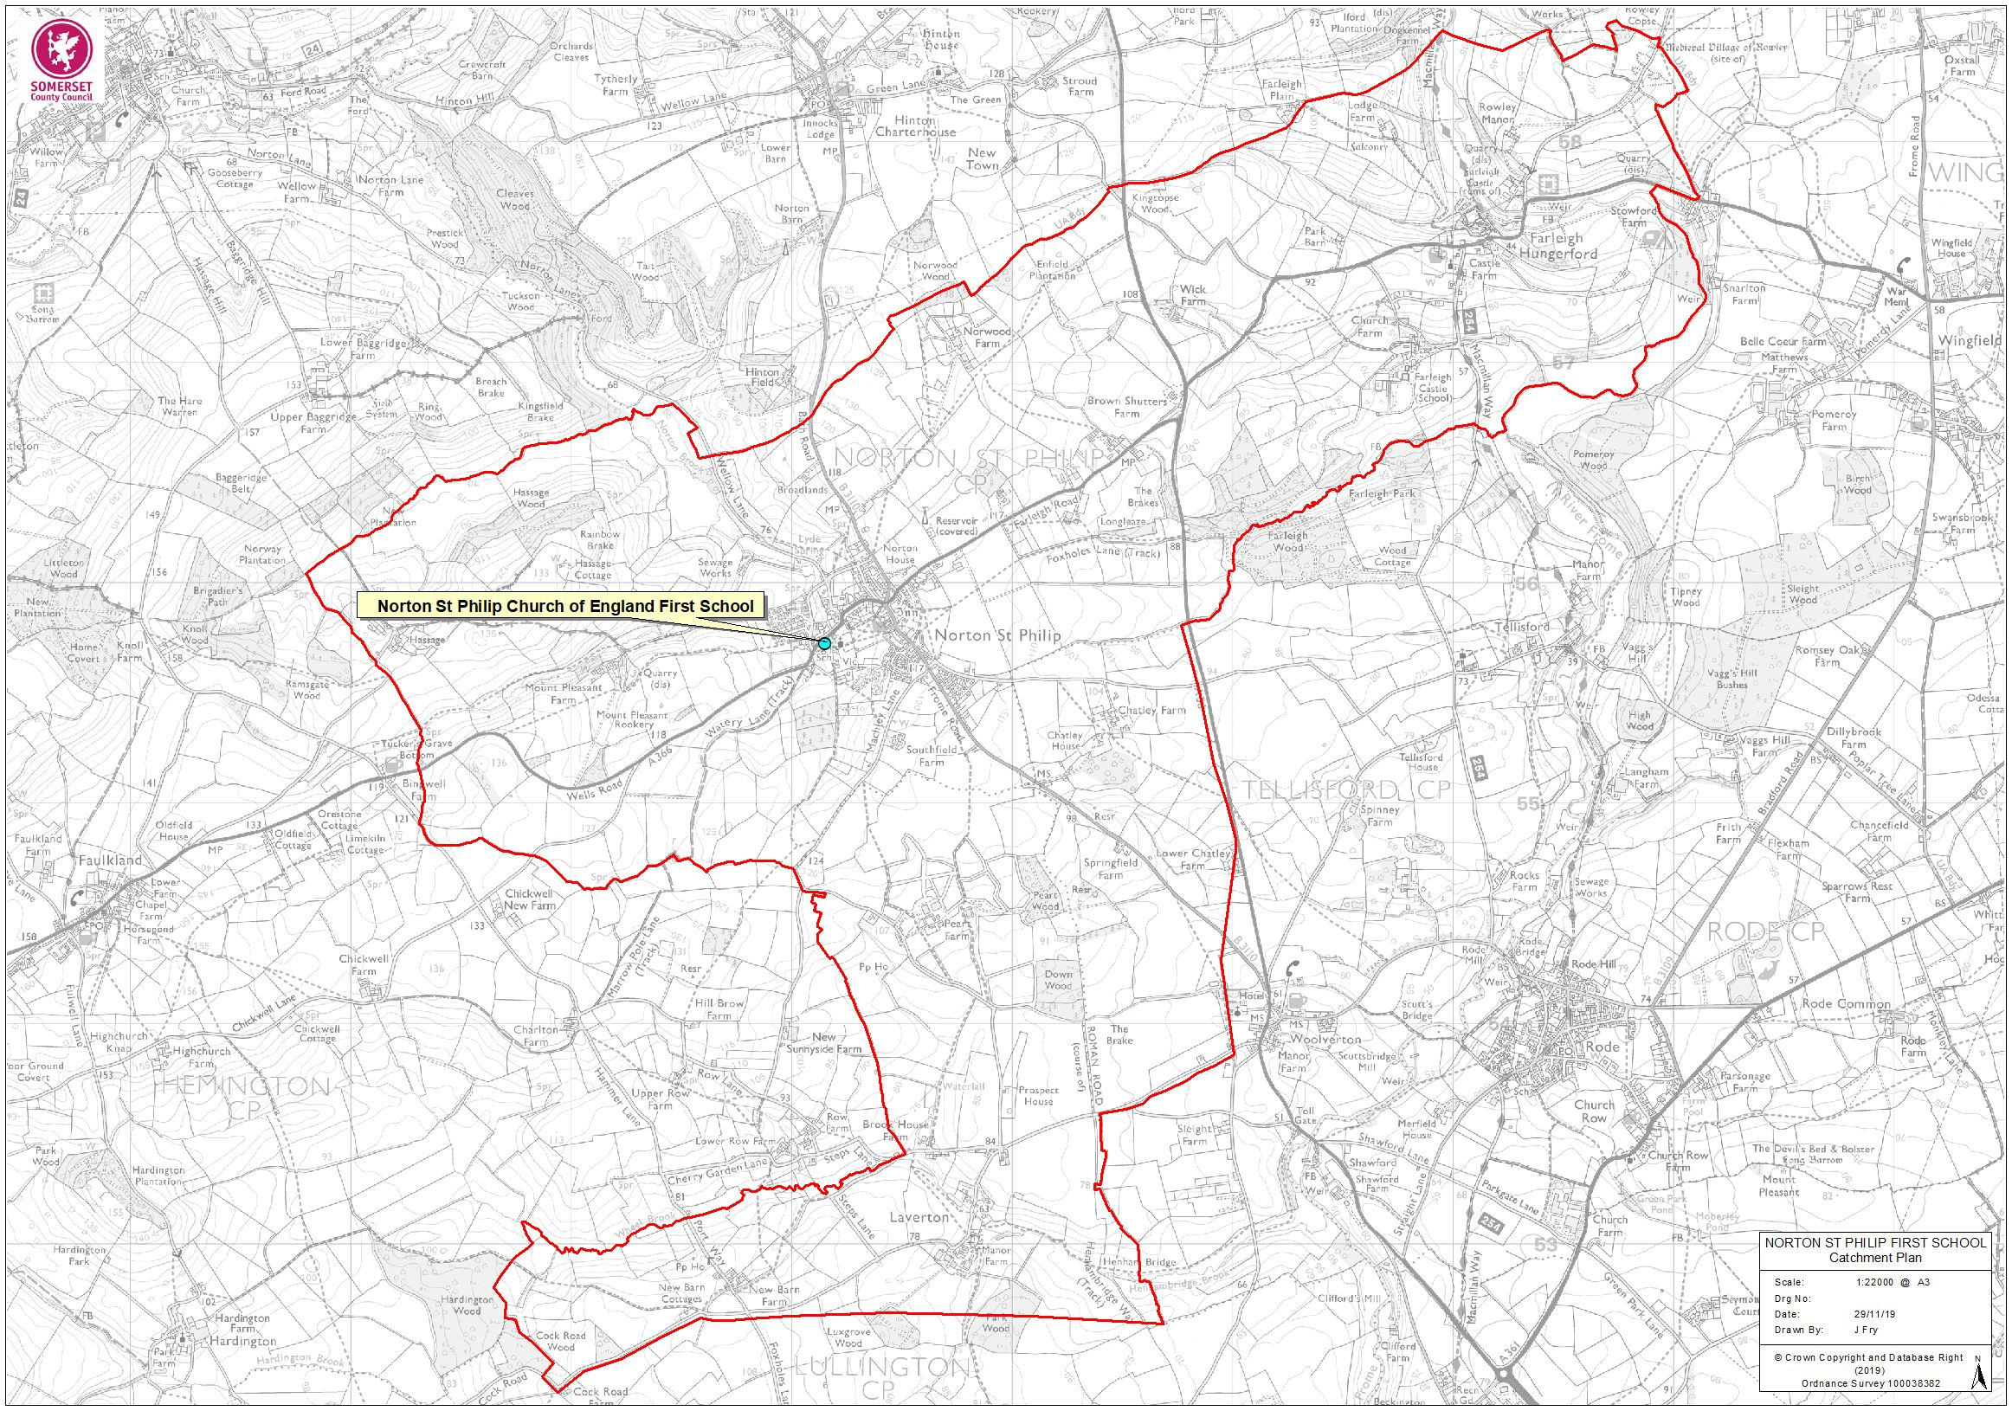
Appendix 2

Supplementary Information Form’ (SIF) for Admissions: 2022/2023

This form must be completed if a parent/carer wishes to provide supplementary information in order to confirm that his/her child satisfies Criterion 4 or 7 of the Oversubscription Criteria applying for Norton St Philip Church of England VA First School.

In the event that during the period specified for attendance at worship, the church has been closed for public worship and has not provided alternative premises for that worship, the requirements of these admission arrangements in relation to attendance will only apply to the period when the church or alternative premises have been available for public worship.

In the event that there are more admission applications received than places available within the required year group, it will be necessary for the Admissions Committee to rank every application according to the Oversubscription Criteria published in the School’s Admission Policy 2021/2022. This will determine a priority for the offer of available places.

A child will only be prioritised against a particular criterion if this completed Supplementary Information Form is submitted in conjunction with the school admission application and in accordance with the procedure set out below. The required evidence must be provided to back up any claim. The parents/carers are responsible for ensuring the school receives the form by the deadline. For admission applications made as part of the ‘normal’ admissions round, which is coordinated by the home local authority (starting or transferring school in September 2021), the admission application form must be submitted to the home local authority by 23:59 hours on 15th January 2022 and the Supplementary Information Form must be submitted directly to the School by the same date.

For applications in connection with a place required in any year group during the school year (In-Year Application) this Supplementary Information Form must be submitted directly to the School Office with the Admission Application Form.

The child who is the subject of this Supplementary Information Form:

Child’s full name:
Child’s date of birth:
Child’s gender
Child’s home address
Child’s postcode
Parent(s) or Carers(s) full name
Parent(s) or Carers(s) contact telephone

The oversubscription criteria | Further information | Requested evidence
Criterion 4:  Children who themselves or their parent(s) are practising members of the Church of England and who live within the Catchment Area. | The Governors define ‘practising’ as ‘attending a Church of England place of worship at least once per month for a minimum period of six months prior to application’. | The Vicar, Parish Priest or Church Warden must sign and date this form to confirm eligibility:  I, _________________________(full name)  confirm my knowledge of this child or family named on page 1 of this form in relation to the Criterion 5.  Signed:  Date:  Contact details:
Criterion 7:  Children who themselves or their parent(s) or carer (s) are practising members of the Church of England and who live outside the Catchment Area. | The Governors define ‘practising’ as ‘attending a Church of England place of worship at least once per month for a minimum period of six months prior to application’. | The Vicar, Parish Priest or Church Warden must sign and date this form to confirm eligibility:  I, __________________________(full name)  confirm my knowledge of this child or family named on page 1 of this form in relation to the Criterion 7.  Signed:  Date:  Contact details:

I confirm that the child named on this Supplementary Information Form satisfies the indicated criterion/criteria. I understand that any offer of a school place may be withdrawn where this claim is found to be misleading or false and that by signing this declaration, I grant the Admission Committee permission to seek further confirmation where it is deemed necessary to do so.

Signed: ___________________________________________ (Parent / Carer)

Name: ____________________________________________ (Parent / Carer)

Date: _____________________________________________ (Parent / Carer)

Notes for clergy or those responsible and authorised to sign supplementary information forms for those applying to church schools under a church attendance criterion

Please note: The recommendation of the Bath & Wells Diocesan Board of Education (DBE) is that clergy do not work in isolation when looking at school admission supplementary information form requests. The DBE strongly recommends that it is best practice to have a sub-committee of at least three members, including clergy, churchwardens and those with responsibility for Sunday school to consider these requests and be authorised to sign the form if it is agreed appropriate. The completion of this form and its return in time to meet the admission application deadlines is critical for the applicant, and without it the child cannot be considered eligible under any church attendance criteria, even if they are regular attendees at church.

In order for the application to be considered under any church attendance criteria within the school’s admissions arrangements, the following must be ensured:

- That the attached form is completed by the applicant and signed by the relevant church representative (vicar, priest, minister, pastor, church warden)

- That the information on the form matches and fulfils the requirements set out in the specific admissions arrangements of the school to which the application is being made. Clergy must be clear that the specific criterion for each school is being met by the applicant and should see the admissions criteria so that they can check.

- The DBE recommends that schools use the criterion that either the child or at least one parent has attended worship at the church at least once a month for a minimum of 6 months prior to the time of the application.

- The DBE does recommend that the child or a parent has attended actual worship and that attendance at toddler groups or other activities that are held at the church does NOT meet the requirements.

- That the completed form, signed by both applicant and the clergy and is submitted in conjunction with the school application form by the closing date for submission of applications.

- That a separate supplementary form be completed for each VA or Foundation church school for which the applicant is applying as each is likely to have differing admissions criteria.

- For applicants who have recently moved, or are about to move to a different area, the Supplementary Information Form should be completed by the clergy at the church where they have been regularly worshipping. It is the responsibility of the applicant to organise this and ensure that the SIF is completed and sent in on time.

The application process is a legal one and every effort MUST be made to ensure that applications and any supplementary forms are completed accurately and on time. If applicants are unsuccessful, they have the right to appeal, and the information provided by clergy can be critical to the outcome of both the application and appeal, particularly where a school is very popular and oversubscribed.

