This week we are History Detectives! With the 75th anniversary of VE day happening on Friday 8th May, we thought it would be a fantastic opportunity for the children to learn more about this monumental day in British history. I have created a range of activities for you to do with your children this week that are all linked to WW2 and Victory in Europe Day. Perhaps you could listen to Winston Churchill’s incredible VE day speech? Your child could watch videos about the life of an evacuee or create a WW2 recipe! You could even host your own VE day party with your family! On the website, and below this grid, you will be able to find videos and resources to support your child’s learning. Don’t forget to email us all your wonderful work. Miss Anderson

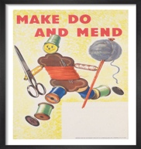  Make do and mend! Can you find something old in your house and recreate it into something new? Perhaps you can use your sewing skills to turn an old t-shirt into a bag or an apron? | Design VE medals for the soldiers who fought in battle.  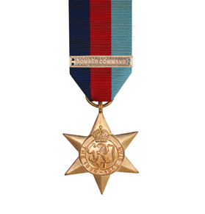 | Look at the recipes from the WW2 cookbook. Could you make some Potato Scones? Or possibly some vegetables with cheese crust? Also – eggless sponge, trench stew and bread pudding. Can you make up your own recipe using the ingredients in a ration book? | Design the front page of a newspaper commemorating the end of WW2.  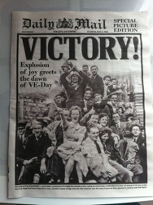  Think about why VE day was an important day in British History.
Create commemorative bunting to put around your house.  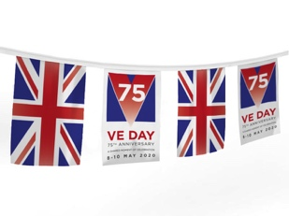 | 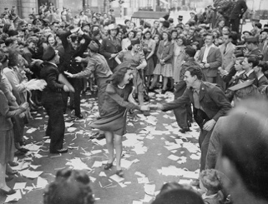  Listen to some popular music from 1945 and create a dance to go with it. Perhaps you could master the lindy hop! | Can you write a poem about the end of the war? Share examples. | 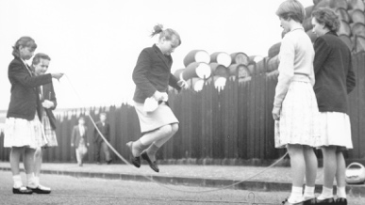  Have a go at playing a popular game from 1945. Can you make up a new game?
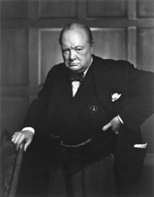  Can you write some facts about Winston Churchill? Could you turn it into an information leaflet? | Write a diary entry from the perspective of an evacuee.  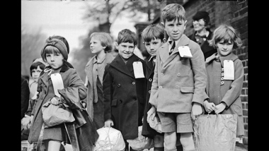 | 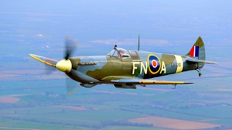  Could you create a model of a Spitfire? You could use any medium for this! Clay, LEGO or bits of recycling. | 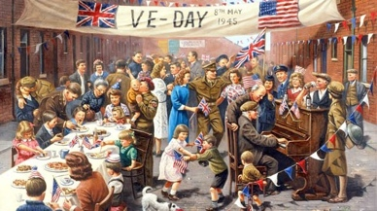  Could you draw/paint a scene of people celebrating the end of the War?

We are History Detectives!

Below are some useful websites to help your child learn more about the events of WW2 and VE Day

Newsround article about VE day - https://www.bbc.co.uk/newsround/48201749

Video explaining WW2 and VE Day- https://www.bbc.co.uk/teach/class-clips-video/history-ks2-ve-day/z7xtmfr

Online video about Evacuees - https://www.bbc.co.uk/teach/class-clips-video/history-ks2-an-evacuees-adventure/zk7hy9q

Horrible Histories video - https://www.bbc.co.uk/cbbc/watch/horrible-histories-songs-ve-day-song

Listen to Churchill’s VE day speech –
https://www.bbc.com/historyofthebbc/anniversaries/may/ve-day-broadcasts
https://winstonchurchill.org/resources/speeches/1941-1945-war-leader/to-v-e-crowds/

Facts and resources about WW2 and VE Day - https://www.theschoolrun.com/homework-help/world-war-2

VE Day PowerPoint for KS1 - https://www.twinkl.co.uk/resource/t2-h-4788-ve-day-powerpoint

VE Day PowerPoint for KS2 - https://www.twinkl.co.uk/resource/t2-h-5399-ks2-ve-day-information-powerpoint

WW2 recipes - https://www.twinkl.co.uk/resource/t2-h-4750-wartime-recipe-booklet
